**CARNAGE**

**EX.NO:04 DATE:19:02:2025 AIM:**

Apply your analytical skills to analyze the malicious network traffic using Wireshark.

**PROCEDURE:**

* Task 1 Scenario
* Task 2 Traffic Analysis Task 1 Scenario:

**Task 1 Scenario**

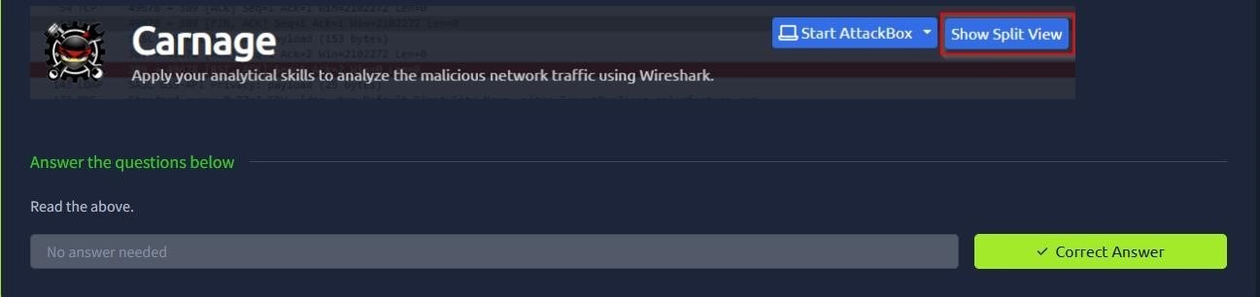

**Task 2 Traffic Analysis**

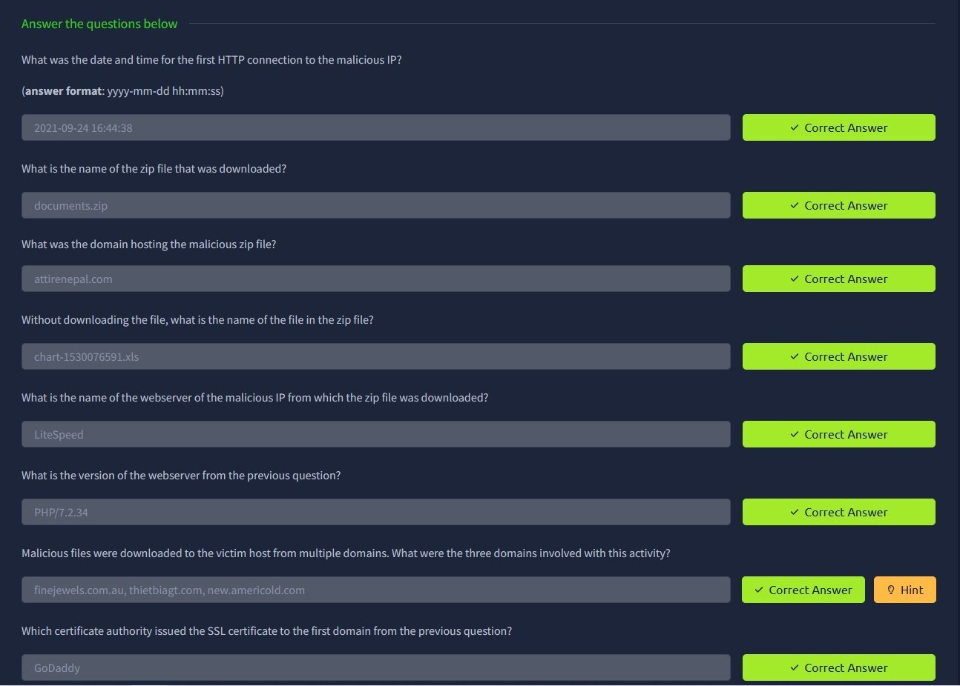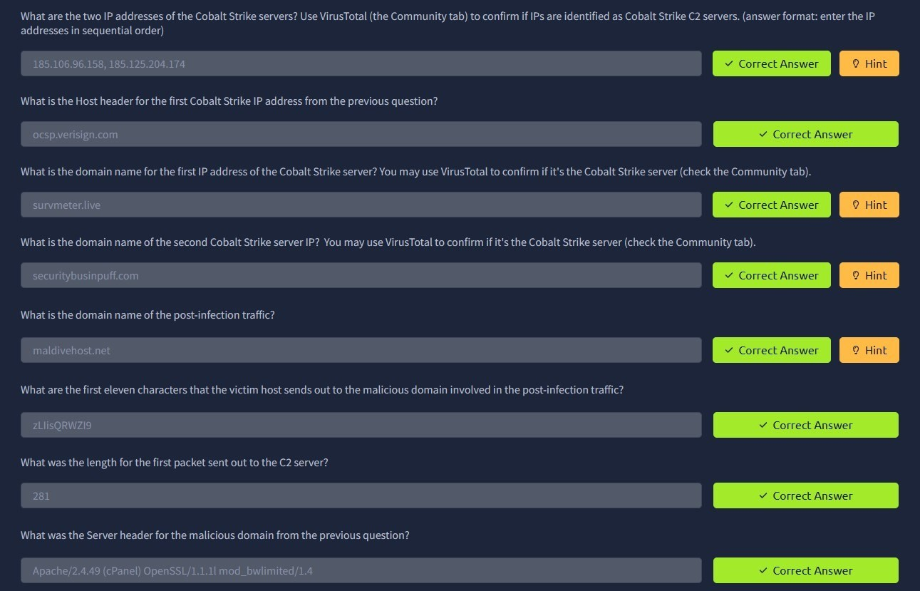

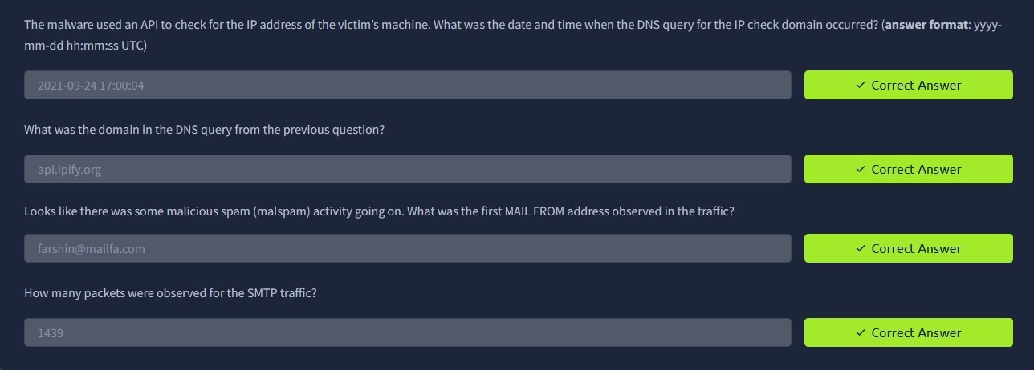

**RESULT:**

Thus the carnage successfully completed in tryhackme platform.

|  |  |  |
| --- | --- | --- |
|  |  |  |